

**Pre-Lab 3**

Name: Socheath Sok,

Class: EE 346 L

Section 6, T/Th

Date: September 25, 2018

**Truth tables and Simplified Boolean expressions**

***Left Turn***

| Input |  | Output |  |
| --- | --- | --- | --- |
| x | y | dir.1 | dir.0 |
| 0 | 0 | 0 | 1 |
| 0 | 1 | 1 | 1 |
| 1 | 0 | 0 | 0 |
| 1 | 1 | 1 | 0 |

$dir.0 = \underline{x} , dir.1 = y$

***Right Turn***

| Input |  | Output |  |
| --- | --- | --- | --- |
| x | y | dir.1 | dir.0 |
| 0 | 0 | 1 | 0 |
| 0 | 1 | 0 | 0 |
| 1 | 0 | 1 | 1 |
| 1 | 1 | 0 | 1 |

$dir.0 =x , dir.1 = \underline{y}$

***Turn Around***

| Input |  | Output |  |
| --- | --- | --- | --- |
| x | y | dir.1 | dir.0 |
| 0 | 0 | 1 | 1 |
| 0 | 1 | 1 | 0 |
| 1 | 0 | 0 | 1 |
| 1 | 1 | 0 | 0 |

$dir.0 = \underline{y }, dir.1 = \underline{x}$

**Flowcharts**

**Turn Left**

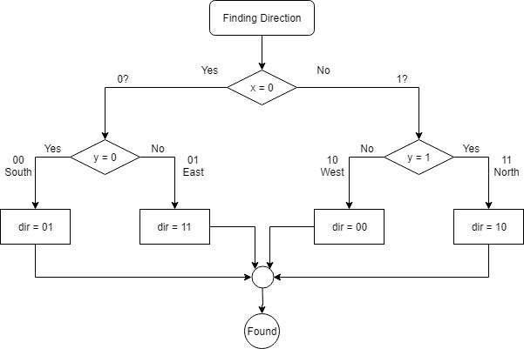

**Turn Right**

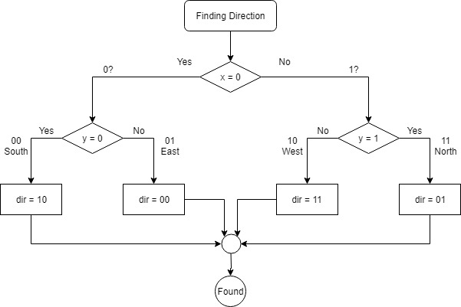

**Turn Around**

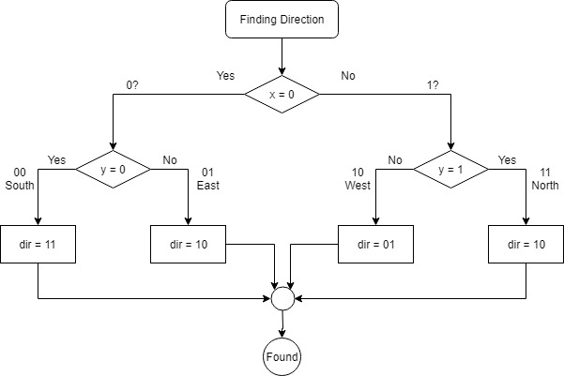

**Question**

1. Logic Truth Table:

| **Input** | **Output** |  |  |
| --- | --- | --- | --- |
| **Logic Gate Selected** | **SW1** | **SW0** | **LED0** |
| **AND** | 0 | 0 | *0* |
|  | 0 | 1 | *0* |
|  | 1 | 0 | *0* |
|  | 1 | 1 | *1* |
| **OR** | 0 | 0 | *0* |
|  | 0 | 1 | *1* |
|  | 1 | 0 | *1* |
|  | 1 | 1 | *1* |
| **EOR (Exclusive OR)** | 0 | 0 | *0* |
|  | 0 | 1 | *1* |
|  | 1 | 0 | *1* |
|  | 1 | 1 | *0* |
| **COM (Inverter)** |  | 0 | *1* |
|  |  | 1 | *0* |

2. The Clear Bit(s) in Register (CBR) instruction performs what logical operation to clear individual bits in a register?

The CBR instruction performs AND operation to clear individual bits in a register.

3. The Set Bit(s) in Register (SBR) instruction performs what logical operation to set individual bits in a register?

The CBR instruction performs ORI (OR Immediate) operation to set individual bits in a register.

4. What byte-wide logical instruction can be used to test if a bit or bits are set?

A logical AND operation can be performed to determine if a bit is set. Assuming that the test bit is set to 1 in one register, if the result it ‘1’, it means the bit in the other register is set. If not, the bit is not set and the result will be ‘0’.

5. Write the single logical instruction below, with inputs r16 and r24, and output r24. Where mnemonics r16 and r24 are two of the AVR’s 32 8-bit general purpose registers. Assume r24 initially contains the byte you want to test, and register r16 contains the test sequence (in our example 000000102).

AND r24, r16